### ABSTRACT

In the few Decades of the project studies and researches have taken place in order to improve security systems and to increase their level of protection in different fields. One of the major problems that security must deal with is the fire outbreak that can happen in everywhere including houses , schools , factories and many other places, and to avoid that or to minimize the damage caused by fire outbreak an IOT technology is used to control such a kind of risk. Iot is a modern system that consist of sensors and switches connected to a central hub which called (gate way. In this project we will use temperature sensor known as (Flame sensor) with Arduino device to detect fire outbreak and to measure the amount of heat intensity generated by a fire outbreak or in a specific location in our house, offices and other places.

It sometimes take to much time for the fire station to reach to the fire outbreak location and works on extinguish the fire and so these sensors will work as an early alarm system which will send an email notification to our mobile phones, fire stations and hospitals if any fire outbreak occurred to let us know the situation clearly and before its too late, we act to avoid significant damage in case the fire outbreak was observed after a long time from its outbreak.Fire is a problem that can happen at any time. Delay in coping with house fires can induce in loss of human life or material. If the fire is not held severely, incidents like house fires can occur and create more significant losses, especially with the increasing number of residents’ settlements in the formation of huddled houses, which will be more challenging to handle in case of a fire.

This research aims to build a prototype system that quickly helps house owners and firefighters to detect fires and gas leaks.This home fire detection system is utilized to measure room temperature and gas levels in a room, then the output of this system is sending information of short messages and alarms.

**CONTENTS**

Page.No

CHAPTER 1

INTRODUCTION 1-4

COMPANY PROFILE

CHAPTER 2

LITERATURE SURVEY 5-27

2.1 EXISTING AND PROPOSED SYSTEM

2.2 FEASIBILITY STUDY

2.3 TOOLS AND TECHNOLOGIES USED

2.4 HARDWARE AND SOFTWARE REQUIREMENTS

CHAPTER 3

SOFTWARE REQUIREMENT SPECIFICATION 28-29

3.1 USERS

3.2 FUNCTIONAL REQUIREMENTS

3.3 NON-FUNCTIONAL REQUIREMENTS

CHAPTER 4

SYSTEM DESIGN 30-31

4.1 SYSTEM PERSPECTIVE

4.2 CONTEXT DIAGRAM

CHAPTER 5

DETAILED DESIGN 32-37

5.1 DATA FLOW DIAGRAM

5.2 USECASE DIAGRAM

5.3 SEQUENCE DIAGRAM

5.4 ACTIVITY DIAGRAM

5.5 FLOW CHART

CHAPTER 6

IMPLEMENTATION 37-41

SCREENSHOTS

CHAPTER 7

SOFTWARE TESTING 42-47

CHAPTER 8

CONCLUSION 48

CHAPTER 9

FUTURE ENHANCEMENT 49

CHAPTER 10

REFERENCES 50

**CHAPTER 1**

**INTRODUCTION**

Ever since mankind first began building structures out of wood rather than stone, fire has been a part of the learning process. In fact, so common have these infernos been throughout history that nearly every major city in the world has been largely burnt to the ground at one time or another in its history. An example of such fire outbreak was in Boston 1872. While not as large a fire as the one in Chicago the year before or the fire that was to ravage San Francisco just over three decades later.

Firefighting requires skills in combating, extinguishing, and preventing fires, responding to emergency calls, operating and maintaining fire department equipment and quarters, and extensive training in performing firefighting activities. The earliest known firefighters were in the city of Rome. In 60 A.D., emperor Nero established a Corps of Vigils (Vigils) to protect Rome after a disastrous fire. It consisted of 7,000 people equipped with buckets and axes, and they fought fires and served as police.

In the 4th century B.C., an Alexandrian Greek named Ctesibius made a double force pump called a siphon. As water rose in the chamber, it compressed the air inside, which forced the water to eject in a steady stream through a pipe and nozzle.

Nowadays, some factories and buildings have proper installation and fire safety and control arrangements such as fire alarm, fire extinguishers, water supply system etc. But the problem is these conventional fire extinguishing systems are not enough to take prompt action during fire outbreak and hence, save life. The best way to reduce these losses is to respond to the emergency situation as quickly as possible. So, there comes the necessity of a standalone fire detection systems. This project therefore seeks to design a microcontroller fire alarm and control system that will continuously monitor the presence of significant amount of heat and activate an alarm and simultaneously switch off the mains of the building, send an SMS alert and extinguish the fire as a safety measure to contain the situation.

## 

## Reasons to Install a Fire Alarm

* + **Fire alarms save lives:** The number one reason to install a fire alarm is to make the building safe for your employees, customers, and tenants. A combination of smoke and heat detectors, sirens and bells, and strobe lights detect fires and alert building occupants, giving them ample time to evacuate in an orderly fashion.
  + **Fire alarms reduce property loss:** While strobe lights and sirens don’t actively put out fires, they alert the people who can. The fire control process begins when trained personnel attack a small fire with an extinguisher and bystanders, guests, or employees call the fire department. Monitored fire alarm systems automatically notify emergency responders and fire trucks dispatch to your location without delay. The faster these responses happen, the sooner the fire is extinguished and the less damage your building sustains.
  + **Fire alarms shorten your recovery time:** Less building damage means shorter downtime until you can reopen for business. This cuts your losses from the fire even more, allowing you to return to business as usual before long.
  + **Fire alarms may qualify you for insurance discounts:** Most insurance carriers offer discounted rates on business insurance policy premiums if you have a code-compliant fire alarm system. In fact, some providers require you to install a fire alarm before they will insure your business.
  + **Fire alarms keep you code-compliant:** If you want to avoid fees and embarrassing PR problems, avoid getting caught up in code-compliance issues. One way to do this is to install a fire alarm in your commercial building.

.

**COMPANY PROFILE**

**Company Profile**

Company Name: Contriver Private Limited

### Logo:

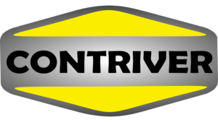

**Website:** **https://contriver.co.in/**

Contriver is a company owned by young people who have recognized the intolerance that is possessed to the society in the field of Food, Health, Education, Agriculture, Fitness, Construction, Engineering, Fashion, Record Producing and On Demand Services.

The founder of Contriver wanted to create a community for the young people who are the future pillars of the nation.

We, Everyone in Contriver work to build a grateful nation by making things come alive every day in our family with great work culture in our enterprises. Our organization’s highest priority is to serve the customer and help them to make a better purchase decision everyday with high quality products which meets the 5s and 7s Standards to cater the global requirements.

Our core values have been framed around the end-user and to serve global audience.

**Vision**

We envision on reaching out to each and every individual around the world providing top-notch consumer products, professional training and technical solutions, within the year 2025.

## **Mission**

* To make our nation a minimum polluted country with more green and sustainable energy that can cater the needs of every class of the society.
* To teach the industrial or real-time engineering to cultivate the best organizational behavior.
* To enrich the value of traditional nutritious food of our country and eradicate the health issues caused by preserved food and oils.
* To construct economical, ergonomically, robust buildings to the middle-class society of the nation.
* To provide every class of people with best in class household service.

**CHAPTER 2**

**LITERATURE SURVEY**

Already many solutions has been proposed and implemented for this problem. These systems make use of one of the following techniques: video surveillance system, video camera sensitive to smoke in day time, cameras sensitive to fire flame at night, detection of heat flux using IR thermal imaging cameras and LIDAR system which detects the smoke particles by backscattering of laser light. All this system has some limitations due to atmospheric conditions such as dust particles, fog, shadows etc. Another method is the use of Visual Cameras that take snapshots of the forest to detect the fire. These cameras were mounted on the top of communication towers.

A rotating motor is installed to provide a full round view of the forest. The images obtained from the camera are processed using program or MATLAB code and are compared with the reference images taken at initial stage. This system also had limitation of high false alarm rate. Also the cost of installation of visual cameras on communication towers was very high. Another method is the use of satellite system to detect the forest fire. The main components of the system are satellite(s) and the base station that collects the data send by the satellite(s) and runs the analyzing algorithm. The raw data from the satellite(s) is processed and then Advanced Very High Resolution Radiometer (AVHRR) instrument is used to detect presence of Hot Spots. However the clouds greatly affect the system.

Forest Fire Surveillance System which consists of WSN was also proposed for detection of forest fires in South Korea. The WSN determines the temperature and humidity after which middleware program and web application analyzes the collected data. However in this approach of detection of forest fire there was some loss of data during communication.

WSN consisting of temperature sensor setup and GPS module was also proposed for detection of forest fire. In this temperature data was transmitted to base station via primary and main antenna using satellite. Some of the limitation of system was installation of too many antennas; continuous power was required to both temperature sensor setup and antennas. In addition to this climatic/seasonal changes can affect the system.

#### **2.1Existing and Proposed System**

#### **System Analysis**

System analysis is a representation of the current system that aims to find out how the system works. It can also define and evaluate obstacles, opportunities, problems, or needs to be expected to propose improvements.

**Existing System Analysis**

The current fire management system still uses conventional methods with assistance, where information related to fires is obtained based on field observations. The following are the steps in the fire handling process that are currently being carried out:

1.The first step for the community or building owner is to detect a fire by looking at the smoke and flames coming from the building.

2.The second step is the building owner/local community looking for contact information/phone number for firefighters.

3,The second step is the building owner/community contacting the firefighters by telephone to ask for help (phone calls will continue until the firefighters are successfully contacted).

4.The fire brigade responds to the community/fire victims. The current fire fighting process does not involve an early detection of fires so that actions are taken based on reports that a fire has occurred. Thus, it has been confirmed that a serious fire has occurred and property damage has occurred, and there may even be fatalities before the officers respond to fire information. Thus, it is necessary to involve a mechanism to be able to provide early warning information about a fire.

#### **Proposed System Analysis**

System analysis conveys the solution of an obstacle that happens in the running system. In the analysis of the proposed system, the fire detection and handling process are divided into 2 stages which are all automated using a microcontroller based on Arduino Uno.

The following is an explanation of the proposed system flowchart, as follows:

1.In the first stage, the tool detects the presence or absence of a potential fire by measuring the temperature in the room using a temperature sensor.

2.In the second stage, if the room temperature is detected above >45 ◦C, the system will activate the siren/alarm indicating a potential fire.

The system will activate the siren/alarm indicating a potential ﬁre as well as sending a text message

containing information on potential ﬁres and also the coordinates for the detection of potential ﬁres via the GSM module to the homeowner and also the ﬁre department’s ofﬁce whose calling number has been registered on the device.

**2.2 Feasibility Study**

The Feasibility of the project is analyzed in this phase and business proposal is put with a very general plan for the project and some cost estimates .During System analysis, the feasibility study of the proposed system is to be carried out. Identifying a fire is ordinary cultivated by introducing fire sensor .Inhabitant notice is cultivated by the establishment of discernible notice apparatuses. The codes require alarm signals be naturally transmitted legitimately to the nearby local group of the fire-fighters or to a focal station observing help that tell the local group of fire fire-fighters of the crisis. This gives the local group of fire-fighters a sign quickly and permits them the chance to quench the fire before it gets too rnoemous..

The fire alarm system has three primary purposes

* Detect a fire
* Alert Occupants of the fire condition
* Alert the local fire Department

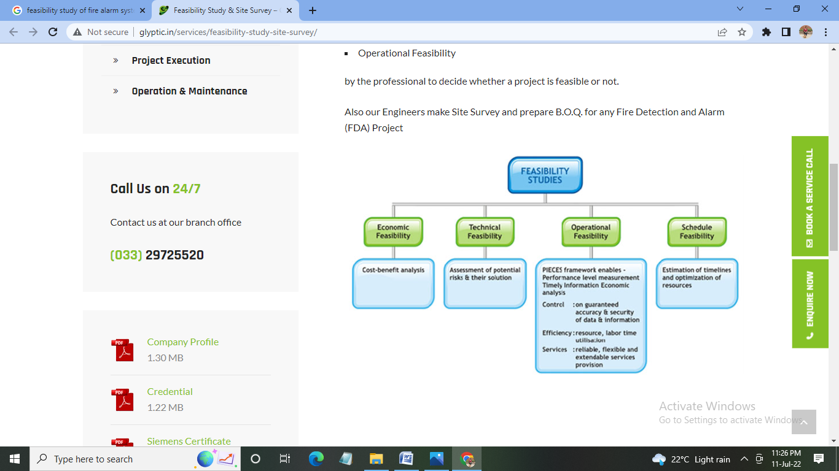

Fig 2.2:Feasibility Study

Four key considerations are involved in the feasibility analysis are:

* Economic Feasibility
* Technical Feasibility
* Operational Feasibility
* Schedule Feasibility
* **Economical Feasibility.**

It is the cost-benefit analysis .Fire accidents have become most common in these days. It is the our responsibility to save the people from such type of attacks and alert them before the fire spreads. considering such situation fire detection systems have been invented and economically helping the peoples by affecting of fire disarsters.

* **Technical Feasibility**

This study is carried out to check the technical feasibility, that is technical requirements of the system. This project is developed within the latest technology. Through the technology may become obsolete after some period of time, due the fact of newer version of the Arduino same software supports older version, the system may still be used. Assesment of potential risks and their solution.

* **Operational Feasibility**

PIECES framework enables-

Performance level measurements Timely information Economic analysis

Control : on guaranted accuracy and security of the data and information.

Efficiency : resource,labor time utilization.

Services : reliable,flexible and extendable services provision.

* **Schedule Feasibility**

Estimation of timelines and optimization of resources

Fire alarm system will aware the people and faster processing of data and faster response to the given to the system.

Therefore the people using the System welcome its development and implementation

Since all the operations related to This application satisfies the benefits that results from the implementation and development of the system, the project is operationally feasible.

**2.3 Tools and Techologies used**

#### **Tools**

#### **ARDUINO UNO R3**

Arduino UNO is a microcontroller board based on the **ATmega328P**. It has 14 digital input/output pins (of which 6 can be used as PWM outputs), 6 analog inputs, a 16 MHz ceramic resonator, a USB connection, a power jack, an ICSP header and a reset button. It contains everything needed to support the microcontroller.

Simply connect it to a computer with a USB cable or power it with a AC-to-DC adapter or battery to get started. You can tinker with your UNO without worrying too much about doing something wrong, worst case scenario you can replace the chip for a few dollars and start over again.

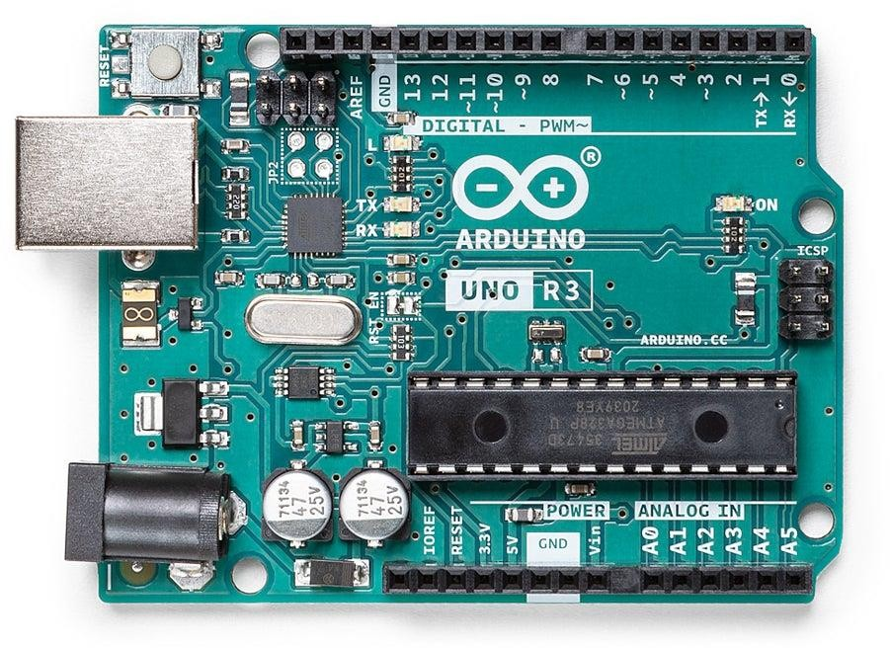

**Fig 2.3.1 Arduino Uno R3**

###### ATmega328P

The classic high-performance, low-power AVR microcontroller

###### Replaceable chip

The ATmega328P can easily be replaced, as it is not soldered to the board.

###### EEPROM

The ATmega328P also features 1kb of EEPROM, a memory which is not erased when powered off.

###### Battery Connector

The Arduino UNO features a barrel plug connector, that works great with a standard 9V battery.

**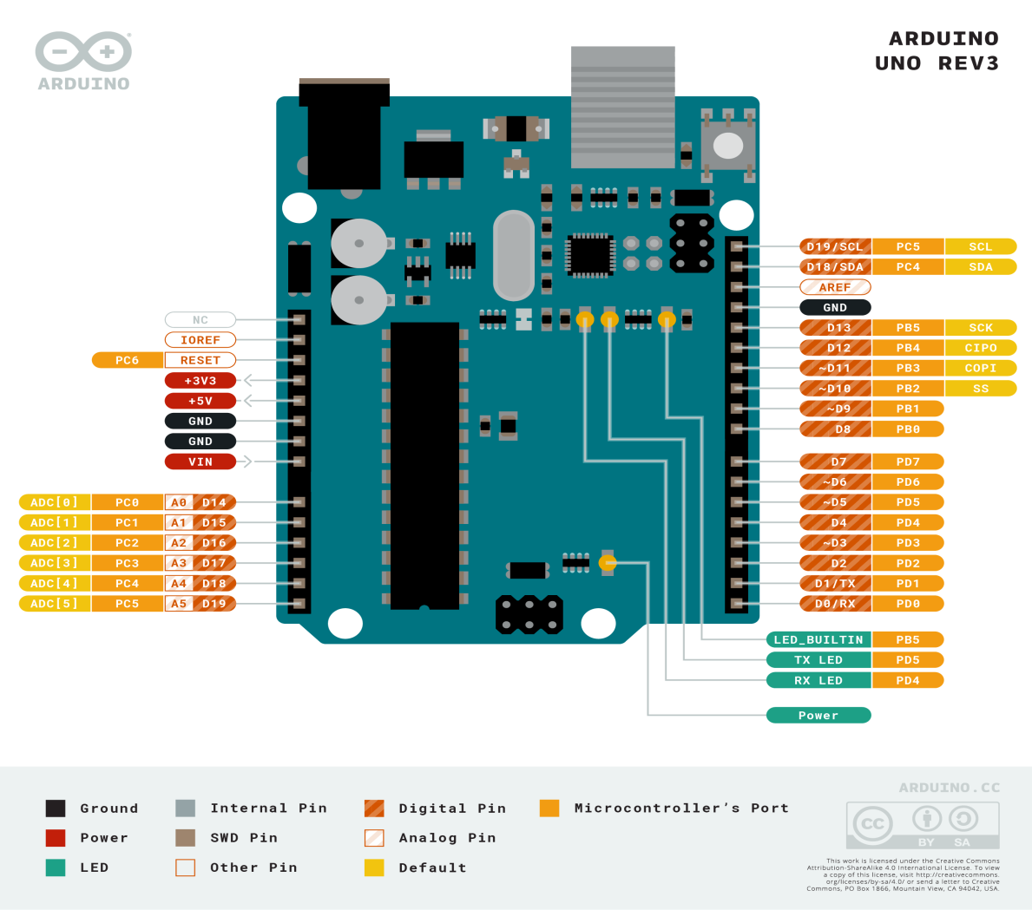**

Fig 2.3.2:SLR Diagram of Arduino UNO R3

**Technical Specification:**

* [Microcontroller](https://en.wikipedia.org/wiki/Microcontroller): [Microchip](https://en.wikipedia.org/wiki/Microchip_Technology) [ATmega328P](https://en.wikipedia.org/wiki/ATmega328P)
* Operating Voltage: 5 Volts
* Input Voltage: 7 to 20 Volts
* Digital I/O Pins: 14 (of which 6 can provide PWM output)
* PWM Pins: 6 (Pin # 3, 5, 6, 9, 10 and 11)
* UART: 1
* I2C: 1
* SPI: 1
* Analog Input Pins: 6
* DC Current per I/O Pin: 20 mA
* DC Current for 3.3V Pin: 50 mA
* [Flash Memory](https://en.wikipedia.org/wiki/Flash_Memory): 32 KB of which 0.5 KB used by [bootloader](https://en.wikipedia.org/wiki/Booting#Boot-loader)
* [SRAM](https://en.wikipedia.org/wiki/Static_random-access_memory): 2 KB
* [EEPROM](https://en.wikipedia.org/wiki/EEPROM): 1 KB
* Clock Speed: 16 MHz
* Length: 68.6 mm
* Width: 53.4 mm
* Weight: 25 g
* ICSP Header: Yes
* Power Sources: DC Power Jack & USB Port

### FLAME SENSOR

A flame detector is a sensor designed to detect and respond to the presence of a flame or fire. Responses to a detected flame depend on the installation but can include sounding an alarm, deactivating a fuel line (such as a propane or a natural gas line), and activating a fire suppression system. The IR Flame sensor used in this project is shown below, these sensors are also called Fire sensor module or flame detector sensor sometimes.

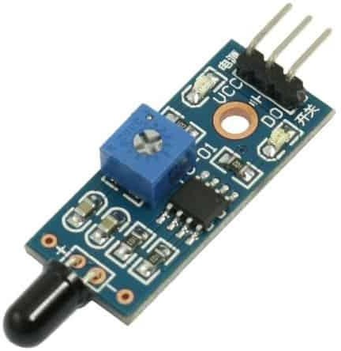

Fig 2.3.3 :Flame Sensor

There are different types of flame detection methods. Some of them are:

Ultraviolet detector, near IR array detector, infrared (IR) detector, Infrared thermal cameras, UV/IR detector etc.

When fire burns it emits a small amount of Infra-red light, this light will be received by the Photodiode (IR receiver) on the sensor module. Then we use an Op-Amp to check for a change in voltage across the IR Receiver, so that if a fire is detected the output pin (DO) will give 0V(LOW), and if the is no fire the output pin will be 5V(HIGH).

In this project, we are using an **IR based flame sensor**. It is based on the YG1006 sensor which is a high speed and high sensitive NPN silicon phototransistor. It can detect infrared light with a wavelength ranging from 700nm to 1000nm and its detection angle is about 60°. The flame sensor module consists of a photodiode (IR receiver), resistor, capacitor, potentiometer, and LM393 comparator in an integrated circuit. The sensitivity can be adjusted by varying the onboard potentiometer. Working voltage is between 3.3v and 5v DC, with a digital output. A logic high on the output indicates the presence of flame or fire. A logic low on output indicates the absence of flame or fire.

The IR flame sensor is used to detect the presence of fire or other infrared source (Flame or a light source of a wavelength in the range of 760 nm to 1100 nm can be detected). It can be used in fire fighting robot or heat seeking robot.

**Features:**

* Small and compact in size
* Adjustable threshold value
* 2 state binary output (logic high and low)
* Easy mounting with a screw hole.

**Specifications:**

On-board LM393 voltage comparator chip and infrared sensing probe.

• Support 5V/3.3V voltage input.

• On-board signal output indication, output effective signal is high level, and the same time the indicator light up, output signal can directly connect with microcontroller IO.

Signal detection sensitivity can be adjusted.

• Reserved a line voltage compare circuit (P3 is leaded out).

• PCB size: 30(mm) x15(mm)

**Applications of Flame Sensor:**

* Hydrogen stations
* Combustion monitors for burners

###### Oil and gas pipelines

* Automotive manufacturing facilities

|  |  |
| --- | --- |
| **Pin** | **Description** |
| Vcc | 3.3 – 5V power supply |
| GND | Ground |
| Dout | Digital output |

###### Nuclear facilities

* Aircraft hangars.

Below is the Pin Description of the Flame sensor Module:

### 3.BUZZER

An audio signaling device like a beeper or buzzer may be electromechanical or piezo electric or mechanical type. The main function of this is to convert the signal from audio to sound. Generally, it is powered through DC voltage and used in timers, alarm devices, printers, alarms, computers, etc. Based on the various designs, it can generate different sounds like alarm, music, bell & siren.

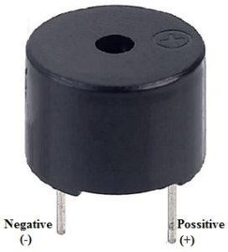

Fig 2.3.4: buzzer

The **pin configuration of the buzzer** is shown below. It includes two pins namely positive and negative. The positive terminal of this is represented with the ‘+’ symbol or a longer terminal. This terminal is powered through 6Volts whereas the negative terminal is represented with the ‘-‘symbol or short terminal and it is connected to the GND terminal.

The **specifications of the buzzer** include the following.

* The frequency range is 3,300Hz
* Operating Temperature ranges from – 20° C to +60°C
* Operating voltage ranges from 3V to 24V DC
* The sound pressure level is 85dBA or 10cm
* The supply current is below 15Ma

#### **LED BULB**

An average 5mm Red LED has a 2V forward voltage drop, and a forward current of 20mA. Don’t forget to use a current-limiting resistor when you connect an LED to your Arduino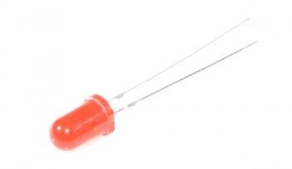

Fig 2.3.5:Red LED

**5.JUMPER WIRES**

A **jump wire** (also known as jumper, jumper wire, jumper cable, DuPont wire or cable) is an electric wire, or group of them in a cable, with a connector or pin at each end (or sometimes without them – simply "tinned"), which is normally used to interconnect the components of a bread board or other prototype or test circuit, internally or with other equipment or components, without soldering.

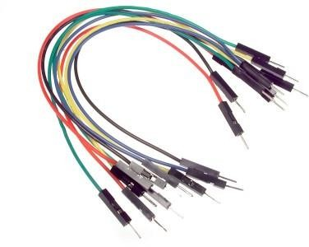

Fig 2.3.6: Jump Wire

Individual jump wires are fitted by inserting their "end connectors" into the slots provided in a breadboard, the header connector of a circuit board, or a piece of test equipment.

.**6.LCD DISPLAY**

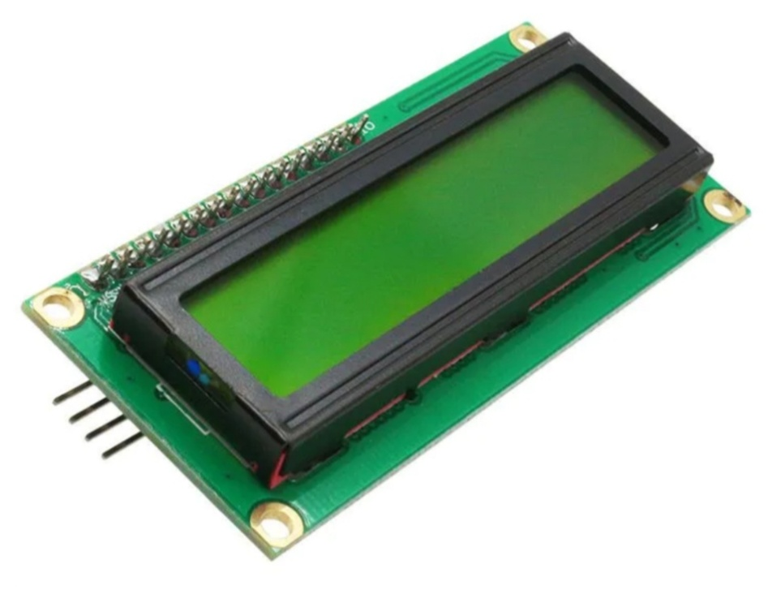

Fig 2.3.7:LCD Display

An LCD screen is an electronic display module that uses liquid crystal to produce a visible image. The 16×2 LCD display is a very basic module commonly used in [DIYs](https://www.electronicsforu.com/category/electronics-projects/hardware-diy) and circuits. The 16×2 translates o a display 16 characters per line in 2 such lines. In this LCD each character is displayed in a 5×7 pixel matrix.

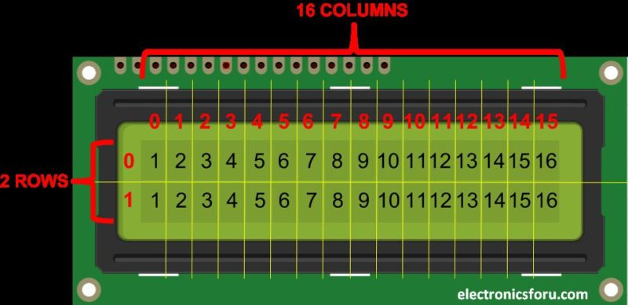

## **Fig 2.3.8:16X2 LCD pinout diagram**

**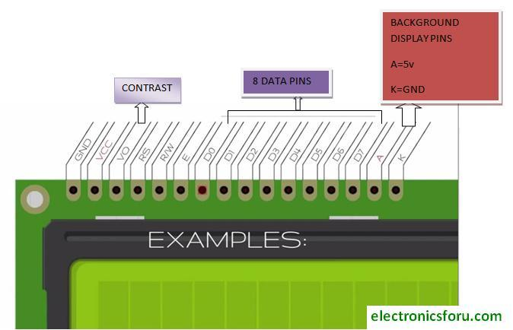**

**Fig 2.3.9:Registers**

### RS (Register select)

A 16X2 LCD has two registers, namely, command and data. The register select is used to switch from one register to other. RS=0 for command register, whereas RS=1 for data register.

**Command Register:** The command register stores the command instructions given to the LCD. A command is an instruction given to LCD to do a predefined task. Examples like:

* initializing it
* clearing its screen
* setting the cursor position
* controlling display etc.

Processing for commands happens in the command register.

**Data Register:** The data register stores the data to be displayed on the LCD. The data is the ASCII value of the character to be displayed on the LCD. When we send data to LCD it goes to the data register and is processed there. When RS=1, data register is selected.

## **Important command codes for LCD**

|  |  |  |
| --- | --- | --- |
| **Sr.No.** | **Hex Code** | **Command to LCD instruction Register** |
| 1 | 01 | Clear display screen |
| 2 | 02 | Return home |
| 3 | 04 | Decrement cursor (shift cursor to left) |
| 4 | 06 | Increment cursor (shift cursor to right) |
| 5 | 05 | Shift display right |
| 6 | 07 | Shift display left |
| 7 | 08 | Display off, cursor off |
| 8 | 0A | Display off, cursor on |
| 9 | 0C | Display on, cursor off |
| 10 | 0E | Display on, cursor blinking |
| 11 | 0F | Display on, cursor blinking |
| 12 | 10 | Shift cursor position to left |
| 13 | 14 | Shift cursor position to right |
| 14 | 18 | Shift the entire display to the left |
| 15 | 1C | Shift the entire display to the right |
| 16 | 80 | Force cursor to beginning ( 1st line) |
| 17 | C0 | Force cursor to beginning ( 2nd line) |
| 18 | 38 | 2 lines and 5×7 matrix |

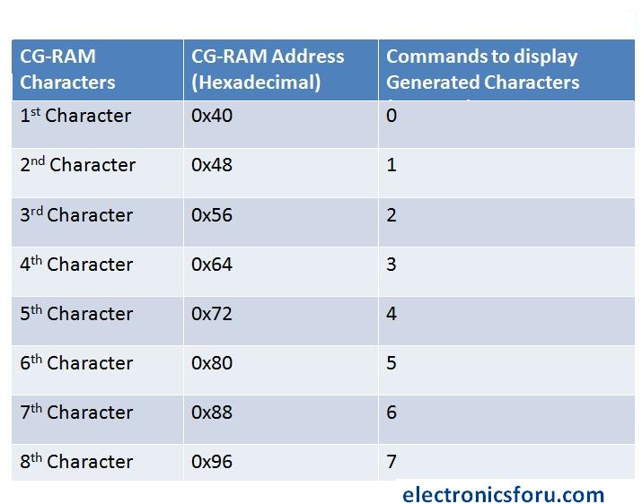

In the table above you can see starting addresses for each character with their printing commands.

**7.BREAD BOARD**

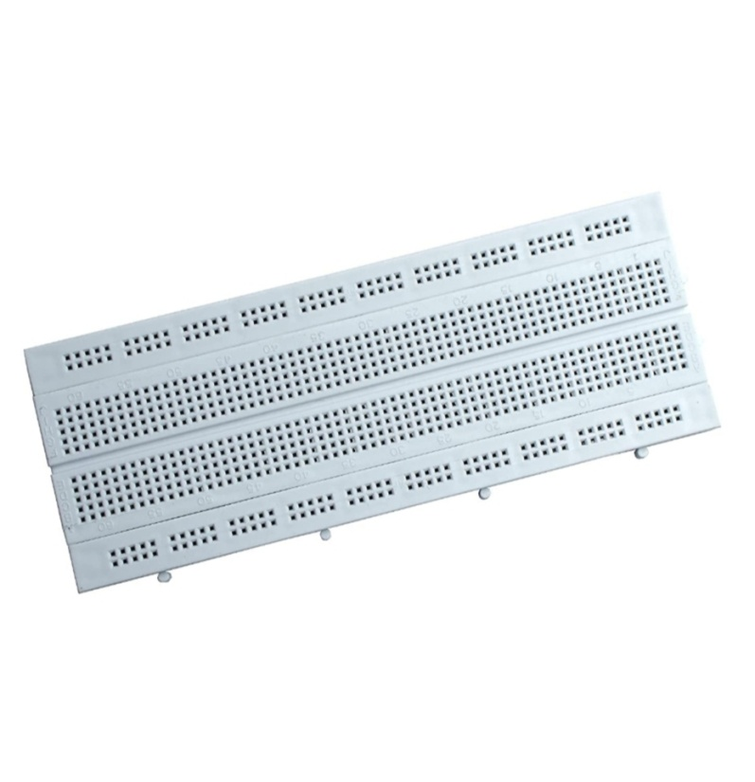

Fig 2.3.10:Bread Board

A breadboard (sometimes called protoboard) is essentially the foundation to construct and prototype electronics. A breadboard allows for easy and quick creation of temporary [electronic circuits](https://www.sciencedirect.com/topics/engineering/networks-circuits) or to carry out experiments with circuit design. Breadboards enable developers to easily connect components or wires thanks to the rows and columns of internally connected spring clips underneath the perforated plastic enclosure. The grid is made up of perfectly aligned spring clip holes that are 0.1″ apart in both the X and Y dimensions.

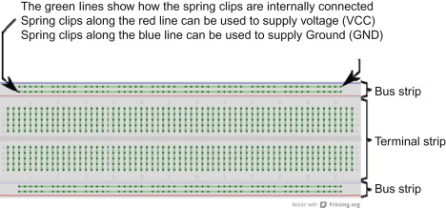

Fig 2.3.11:BreadBoard

A breadboard can be divided into two segments, which are called the bus strip and the terminal strip.

The bus strip consists of two long lines of spring clips running across the board, these lines can be used to provide [supply voltage](https://www.sciencedirect.com/topics/engineering/supply-voltage) (VCC) and ground (GND) to the circuit. Typically, the supply voltage line is marked in red and the ground line is marked in blue (or black on some boards). All spring clips along each line are internally connected, making both supply voltage and ground signals conveniently accessible from any part of the breadboard.

**What Is VCC?**

VCC is the supply voltage that the [microcontroller](https://www.sciencedirect.com/topics/engineering/microcontroller) system uses. The LaunchPad can run properly when a supply voltage of 1.8–3.6 V is available. In most cases, the VCC of our MSP430-based projects will be ~3 V. We will use this terminology and referencing this supply voltage throughout the book.

**What Is Ground?**

All electrical current in a system needs to flow back to ground. In a typical microcontroller project, all components flow back to Ground, which is why this is usually referred to as “common ground.” At GND, this is usually a 0-V reading. We will touch on VCC and GND throughout the book, so don’t worry if this sounds foreign!

The terminal strip is the main area that can be used to populate the various circuit components. It is usually separated into two sides by a notch that runs along the middle of the board. Each side has many lines that are made up of five internally connected spring clip holes. The five spring clips on each line of the terminal strip are connected internally, allowing for component connections.

**Connecting to a Breadboard**

There are many breadboard-friendly components that are available for us to use and prototype with. We can easily identify breadboard-friendly components by their footprint.

Some through-hole-friendly components have long and wiry legs such as LEDs or [resistors](https://www.sciencedirect.com/topics/engineering/resistor). Many common discrete components are typically very breadboard-friendly thanks to their bendable legs. You can easily bend the legs into the desired shape and size and insert them into any of the spring clip holes on the breadboard to enable different types of circuit designs.

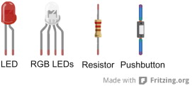

In addition to some of the example components above, some integrated circuits (ICs) or chips also come in breadboard-friendly form-factors. The MSP430G2553 microcontroller found on our LaunchPad is one of those devices. The MSP430G2553 has legs that are perfectly spaced to fit right into the two rows of spring clips along each side of the notch that divides our terminal strip. The official package name for this type of chip is Dual-Inline Package (DIP). The spacing between the two rows of pins on a DIP package is 0.3″, which is exactly three times the spacing between the spring clips on the breadboard. This means that if needed, we can remove the MSP430G2553 device from our LaunchPad and plug it into a breadboard for further flexibility.

**8.10k Potentiometer**

**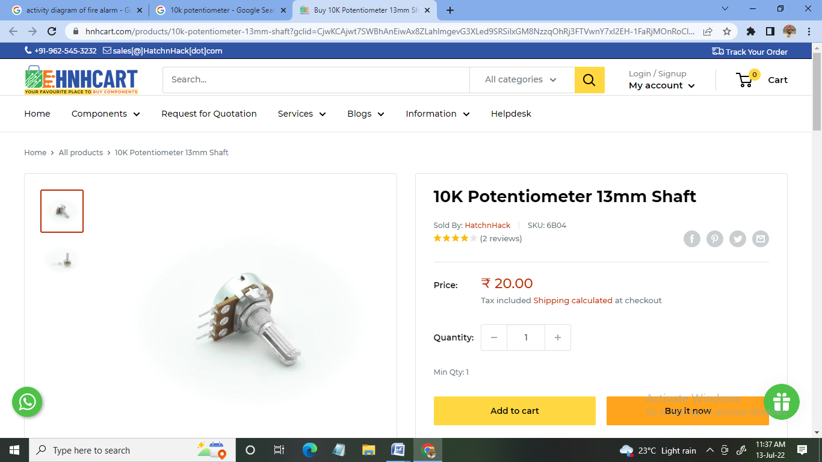**

This adjustable or Variable resistor are PCB mountable and has 3 terminals. The voltage between the terminal varies as the preset is rotated. The Variable resistors are used for variation voltage as per the need in a circuit.

New 10K Ohm rotary potentiometer variable resistor. This potentiometer has a resistance tolerance of **+- 5%** and an independent linearity of +- 0.25%.

[[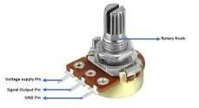](https://www.google.com/search?sa=X&bih=657&biw=1366&hl=en-GB&q=Why+do+we+use+10k+potentiometer?&tbm=isch&source=iu&ictx=1&vet=1&fir=-ntsUwblrno_tM,hH6mdMnpEVH7sM,_&usg=AI4_-kQKCmR70zq-2qaySn4NvrB8EkF5qw&ved=2ahUKEwjlt764mfX4AhVD3nMBHT8_BtoQ9QF6BAgREAE#imgrc=-ntsUwblrno_tM)](https://www.google.com/search?sa=X&bih=657&biw=1366&hl=en-GB&q=Why+do+we+use+10k+potentiometer?&tbm=isch&source=iu&ictx=1&vet=1&fir=-ntsUwblrno_tM%252ChH6mdMnpEVH7sM%252C_&usg=AI4_-kQKCmR70zq-2qaySn4NvrB8EkF5qw&ved=2ahUKEwjlt764mfX4AhVD3nMBHT8_BtoQ9QF6BAgREAE" \l "imgrc=-ntsUwblrno_tM)

Fig 2.3.12:10Kpot

Potentiometers are very useful in changing the electrical parameters of a system. It is a single turn 10k Potentiometer with a rotating knob. These potentiometers are also commonly called as a rotary potentiometer or just POT in short.

**SOFTWARE DETAILS**

**1. ARDUINO IDE**

The Arduino Integrated Development Environment - or Arduino Software (IDE) - contains a text editor for writing code, a message area, a text console, a toolbar with buttons for common functions and a series of menus. It connects to the Arduino hardware to upload programs and communicate with them.Programs written using Arduino Software (IDE) are called **sketches**. These sketches are written in the text editor and are saved with the file extension info.

The editor has features for cutting/pasting and for searching/replacing text. The message area gives feedback while saving and exporting and also displays errors. The console displays text output by the Arduino Software (IDE), including complete error messages and other information.

## Introduction to Arduino IDE | Arduino Programming Tutorial | Electronics funFig:2.3.13:Arduino IDE

## FUNCTIONAL REQUIREMENTS

* + - A buzzer gives an automatic signal by a beep if the system has recognized a potential fire.
    - Red led bulb which is connected to the Arduino will turn On when the fire is detected.
    - In the Lcd Display Its shows the Flame is Detected or Not Detected.

### Main Functions and Uses:

The majority of its components are written in JavaScript for easy editing and compiling. While its primary intention is based around writing codes, there are several other features worth noting. It has been equipped with a means to easily share any details with other project stakeholders. Users can modify internal layouts and schematics when required. There are in-depth help guides which will prove useful during the initial installation process. Tutorials Arduino IDE can be implemented within Windows ([11](https://windows-11.en.softonic.com/), 10, 8.1, 8, 7), Mac and Linux operating systems. are likewise available for those who might not have a substantial amount of experience with the Arduino framework.

Other Accessories

There are several other advantages associated with Arduinno IDE. For instance, a version designed for Google Chrome can be purchased through a small monthly fee. Users have access to an online store and it will automatically detect any existing Arduino boards that are connected to a personal computer.

### PROS

* This is open-source software and no subscription fees will be necessary.
* Enhanced and intuitive tools provide users with access to advanced coding applications.

### CONS

* Arduino IDE is meant for those with coding experience.

There is no telephone number to call the fire fighter.

#### **TECHNOLOGIES**

#### **IOT**

#### Internet of things describes an emerging trend where a large number of embedded devices are connected to the internet these connected devices communicate with people and other things and Often provide sensor data to cloud storage and cloud computing power and increased device connectivity in enabling this trend IOT solutions are built for many vertical applications such as environment monitoring,health monitoring,vehicle fleet monitoring, and home automation.

#### These are number of concerns about the risks in the growth of iot technologies and products especially in the areas of privacy and security and consequently industry and governmental moves to address these concers have begun including the development of international and local standards guidelines and regulatory frameworks.

#### **How does it Works**

The internet of things, or IoT, is a system of interrelated computing devices, mechanical and digital machines, objects, animals or people that are provided with unique identifiers (UIDs) and the ability to transfer data over a network without requiring human-to-human or human-to-computer interaction.

The micro-controller is programmed to turn on the buzzer, when the temperature & the smoke reach a threshold value.

IOT Based Fire Alerting System uses two Sensors, namely, Temperature and Smoke sensors. There is an ADC convertor, which converts the analog signals received at the sensor end to digital and then transmits them to the micro-controller, Arduino. The micro-controller is programmed to turn on the buzzer, when the temperature & the smoke reach a threshold value.

At the same time, Arduino sends the data to the Wi-Fi module ESP8266. ESP8266 is a chip which is used for connecting micro-controllers to Wi-Fi network. ESP8266 will then the following data to the IOT website, where, authorized people can take appropriate measure in order to curb the fire.

**Embedded C**

Embedded C is most popular programming language in software field for developing electronic gadgets. Each processor used in electronic system is associated with embedded software.

Embedded C programming plays a key role in performing specific function by the processor. In day-to-day life we used many electronic devices such as mobile phone, washing machine, digital camera, etc. These all device working is based on microcontroller that are programmed by embedded C.

## **Embedded System Programming:**

**Basic Declaration**

Let's see the block diagram of Embedded C Programming development:

Embedded C Programming with Keil Language2

Fig 2.3.14:Embedded C

Function is a collection of statements that is used for performing a specific task and a collection of one or more functions is called a programming language. Every language is consisting of basic elements and grammatical rules. The C language programming is designed for function with variables, character set, data types, keywords, expression and so on are used for writing a C program.

The extension in C language is known as embedded C programming language. As compared to above the embedded programming in C is also have some additional features like data types, keywords and header file etc is represented by

#include**<microcontroller** name.h**>**

#### **Artificial Intelligence**

#### Artificial intelligence is **the simulation of human intelligence processes by machines, especially computer systems**. Specific applications of AI include expert systems, natural language processing, speech recognition and machine vision

#### **Use of AI Techniques for Residential Fire Detection in Wireless Sensor Networks**. Early residential fire detection is important for prompt extinguishing and reducing damages and life losses. To detect fire, one or a combination of sen- sors and a detection algorithm are needed.

### How does AI work?

As the hype around AI has accelerated, vendors have been scrambling to promote how their products and services use AI. Often what they refer to as AI is simply one component of AI, [such as machine learning](https://www.techtarget.com/searchenterpriseai/feature/Common-sense-in-AI-remains-elusive). AI requires a foundation of specialized hardware and software for writing and training machine learning algorithms. No one programming language is synonymous with AI, but a few, including Python, R and Java, are popular.

In general, AI systems work by ingesting large amounts of labeled training data, analyzing the data for correlations and patterns, and using these patterns to make predictions about future states. In this way, a chatbot that is fed examples of text chats can learn to produce lifelike exchanges with people, or an image recognition tool can learn to identify and describe objects in images by reviewing millions of examples.

#### **2.4 HARDWARE AND SOFTWARE REQUIREMENTS**

HARDWARE REQUIREMENTS

* Processor : Intel core 2duo or Higher version
* RAM : 2GB or Higher end
* Hard Disk :500GB or higher end
* Mouse :Wireless Mouse
* Desktop :15 inch display

#### SOFTWARE REQUIREMENTS

#### Operating System : Windows 7 or above

#### Application : Arduino IDE.

Arduino IDE (Integrated Development Environment)

It has three stages for developing this fire detection alarm system.

* Connect hardware
* Write & upload code to Arduino UNO
* Test our developed system

**CHAPTER3**

**SOFTWARE REQUIREMENT SPECIFICATION**

Software requirements are very important to implement and develop the project of Arduino.

**3.1 Users:**

* Admin
* User

**Admin:**

The transmitter circuit transmits the commands required to operate the System.

The Receiver will receives the Message from the Arduino and detect the fire is Sensoring or Not.The Buzzer will make a sound to Wake a Owner of the System and the LED bulb will turns on and When the flame is detected.

**User:**

First user can Setup the Components in Step by Step it will check the authentication of the project its correct.

The modules operates by inducing the currents in Fire Detection and responds when its occurs a nice on buzzer signals when it detects something and onboard potentiometer allow adjustment of sensitivity.

**3.2 Functional Requirements**

* **Rapid Detection**:

The system must be able to detect a fire rapidly (within seconds, not minutes).

* **3D Location**:

The system must be able to accurately determine the three-dimensional position and volume of the flames in 3-dimensional space.

* **Automatic, Accurate, Dynamic Aiming**:

The system must be able to quickly aim a large volume of water directly onto the flames, and it must be able to dynamically follow the flames if the fire grows or spreads.

* **Multiple Flames**:

The system must be able to handle multiple fires simultaneously.

* **Automation and Autonomy**:

The system must be able to activate and function completely autonomously, without any external network or power and without any human intervention.

* **Web Server**: the system must have a built in web-server for system monitoring and allow for remote control by designated persons. This provides a number of benefits, including allowing firefighters to remotely control each nozzle, allowing a central command center to activate nozzles on neighboring buildings to self-protect and support extinguishing, and providing personnel with real-time alerts—both to fires detected as well as to any functional errors on the system, should they occur.

**3.3 Non functional Requirements**

* Usability

Easy interface for user to monitor fire detection

* Reliability

Easy to use

Should work in all the conditions

* Performance

Should not take more time to detect the Fire its is so fast

* Supporttability

Contain easy to understand code with provisions for future enhancement

#### 

# CHAPTER 4

# SYSTEM DESIGN

In this project we are combining two things together. Hardware and software. As we are coding in the microcontroller and the software we need to be aware of the developing process of the application and the hardware. As we have used SDLC (System development life cycle) method to demonstrate the developing steps of the hardware and the software. So, for system design, we have used certain criteria that could combine both software and hardware in an orderly manner.

**4.1 System Perspective**

DFD level 0 on the home fire detection system built is shown the figure. In this perspective, there are three processes, 1.0—process, 2.0—tool checking, and 3.0—confirmation. The admin aims to input the data needed for the system configuration to be built and collected on the Arduino system. After the data is stored on the Arduino system, people only need to check the tools installed at their houses. The citizens will receive notification of gas leaks and potential fires that occur. The last process is when a house fire happens, the Arduino system will send information in the form of an SMS to the fire department, and then it will be confirmed that the fire incident occurred.

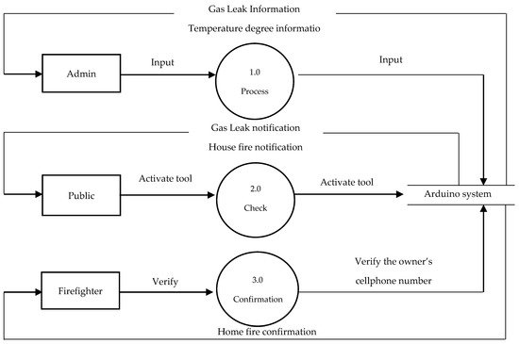

**Fig 4.1:DFD level0**

**4.2 Context Diagram**

The software for the system design to be built is a context diagram (a description of the system designed), called DFD (Data Flow Diagram) level 0 .The context diagram shown in **Figure** is a general explanation of the entities involved. The entities in this system are the admin, community, and firefighters. The admin will input the data required to design this system and receive the information contained in the system. The citizens will receive notifications of gas leaks. Notification of house fires will be sent by text message and alarm if there is a fire. The fire brigade will receive information on the occurrence of fires and confirm fires in peoples houses,

Fig 4.2:Context Diagram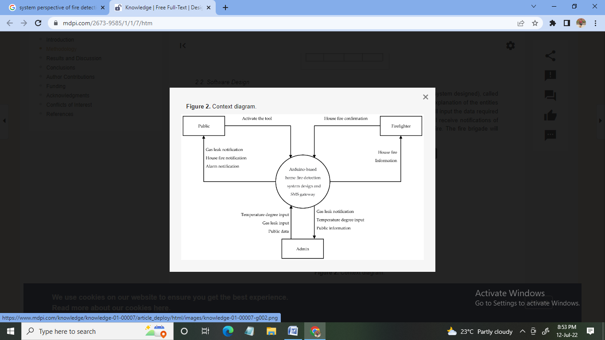

#### **CHAPTER 5**

#### **DETAILED DESIGN**

#### **5.1** **DATA FLOW DIAGRAM**

A dataflow diagram is a graphical representation of the "flow" of data through an information system, modeling its process aspects. A DFD is often used as a preliminary step to create an overview of the system without going into great detail, which can later be elaborated. DFDs can also be used for the visualization of data processing. A DFD shows what kind of information will be input to and output from the system, how the data will advance through the system, and where the data will be stored.

The microcontroller is the main part of this project. Here in the diagram that the Flame sensors will communicate Arduino to get the resultant output of Temperature and Heat.

Flame Sensor

ARDUINO

CONTROLLER

BUZZER

POWER SUPPLY

Fig 5.1: DFD 1st Level:

#### 

#### Fig 5.2:DFD 2nd Level

#### **5.2 USECASE DIAGRAM**

A use case diagram at its simplest is a representation of a user's interaction with the system that shows the relationship between the user and the different use cases in which the user is involved. A use case diagram can identify the different types of users of a system and the different use cases and will often be accompanied by other types of diagrams as well. While a use case itself might drill into a lot of detail about every possibility, a use case diagram can help provide a higher-level view of the system. It has been said before that "Use case diagrams are the blueprints for your system". They provide the simplified and graphical representation of what the system must actually do.

#### Screenshot (49).png

Fig 5.3: Usecase

**5.3 SEQUENCE DIAGRAM**

A sequence diagram simply depicts interaction between objects in a sequential order i.e. the order in which these interactions take place. We can also use the terms event diagrams or event scenarios to refer to a sequence diagram.

* + 1. **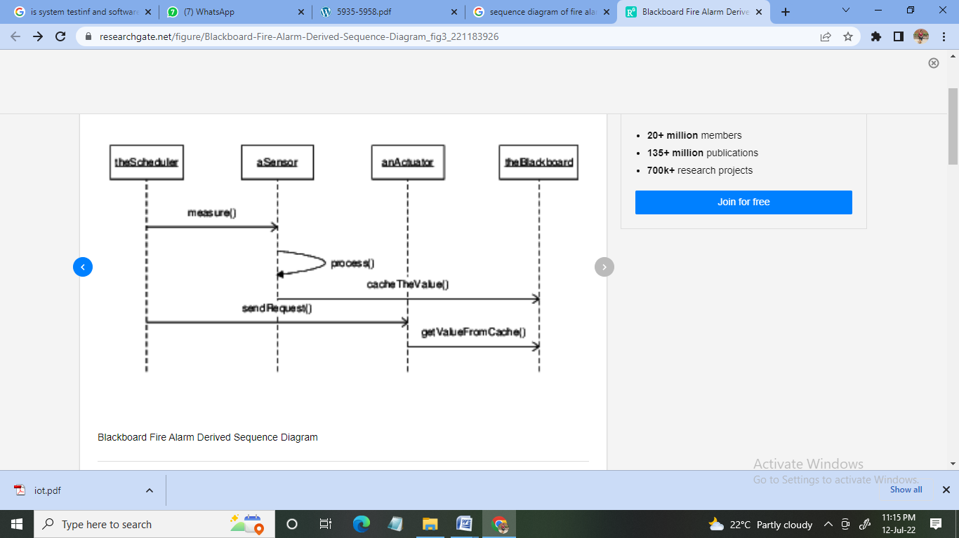**
    2. **Fig 5.3: Sequence Diagram**
    4. **5.4 FLOW CHART OF PROPOSED SYSTEM**

The whole system is controlled by a firmware which is implemented in embedded IC which was built by a compiler (Arduino). Then the program is downloaded to the 8-bit Atmega328P microcontroller.

START

Initialize Circuit

Read

Temperature

No

If

Temp is >=40

Yes

STOP

Switch ON Buzzer and Red Led

* + 1. Fig 5.4 : **FLOW CHART OF PROPOSED SYSTEM**

**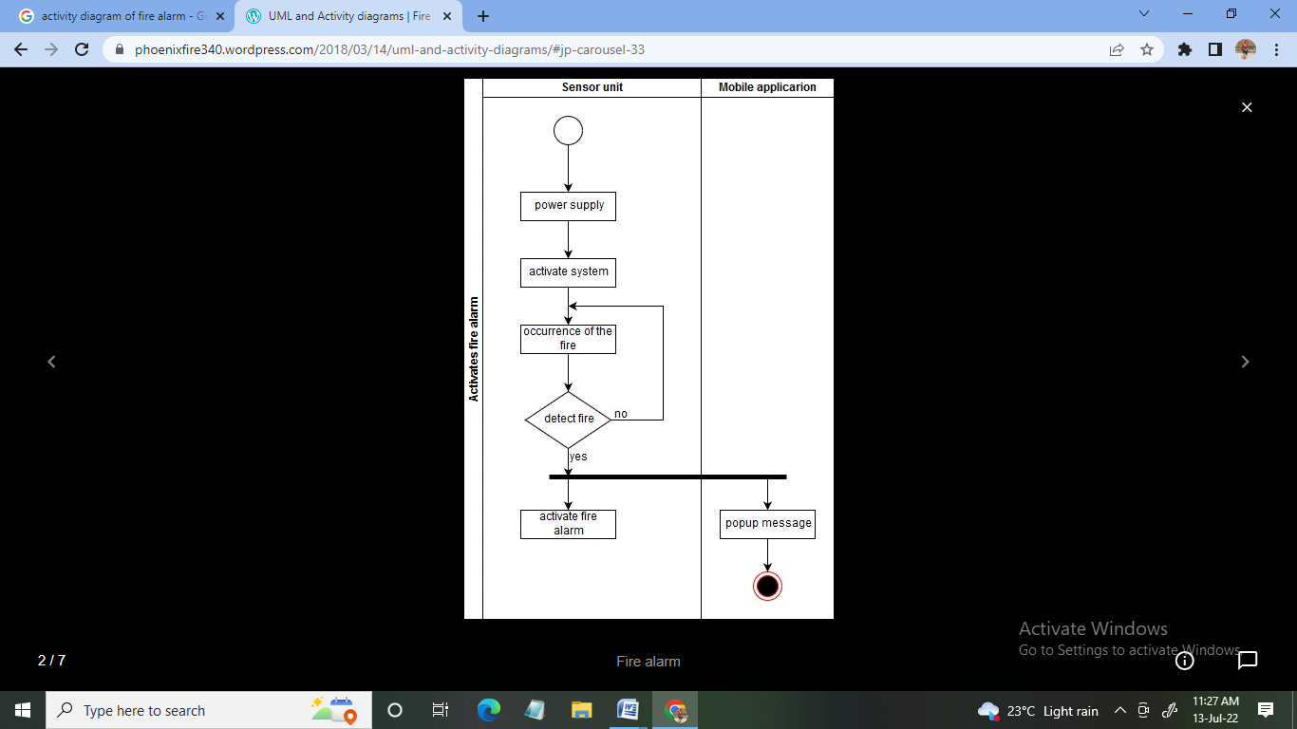5.5 Activity Diagram**

An activity diagram is a behavioral diagram i.e. it depicts the behavior of a system. An activity diagram portrays the control flow from a start point to a finish point showing the various decision paths that exist while the activity is being executed.

**Fig 5.5:Activity Diagram**

**CHAPTER 6**

**IMPLEMENTATION**

This is the phase of the lifecycle where all the components are implemented and connected in real time scenario so that the ultimate targets and objects are achieved accordingly. This is the part where most of the practical approach comes in hand. All the previous Designing, analysis and coding come to the scenario at this phase. Here we describe the step by step different functionality we undertook to achieve the end goal in every module with their outputs. As this is the most crucial part of the project and we need to be more conscious than any other parts, we have considered this is the main part of the project. Understanding importance of this phase we have divided it into different steps whilst preparing the implementation process for our weather monitoring system project as follows:

Stage one :Arranging nedded Components

Stage two: Functionality

Stage three : Wiring and Circuited

Stage four : Assembling Arduino and sensors

Stage five: Power Supply

Stage Six: Coding

**Program code:**

#include <LiquidCrystal.h>

LiquidCrystal lcd(2, 3, 4, 5, 6, 7); // LCD Display (RS,EN,D4,D5,D6,D7)

#define flamePin 10 // Flame Sensor Connected To Arduino

#define buzzerPin 11 //Buzzer Connected To Arduino

void setup() {

Serial.begin(9600);

Lcd.begins(16,2);

PinMode(buzzerPin,OUTPUT);

pinMode(flamePin,INPUT);

lcd.setCursor(0,0);

lcd.print(“Calibrating”);

for(int i=0;i<15;i++){

if(i==4)

{

lcd.setCursor(0,1);

lcd.print(“.”);

delay(500);

}

Lcd.setCursor(11,1);

Lcd.print(“Done”);

Delay(1000);

Lcd.clear();

Lcd.print(“Sensor Active”);

Delay(1500);

Lcd.clear();

}

Void loop() {

Int Flame=DigitalRead(flamePin);

If(Flame==LOW)

{

digitalWrite(buzzerPin,HIGH);

lcd.setCursor(0,0);

lcd.print(“Flame:”);

lcd.setCursor(0,1);

lcd.print(“is Detected”);

Serial.print(Flame);

Serial.print(“\t”);

Serial.print(“Flame is Detected”);

}

else if(Flame==HIGH)

{

**ScreenShots:**

This project is simple in connections and dumping. Connect the circuit as shown in the above image. Make sure that all connections are correctly done so that there will be no issues after dumping the code.

Place a match stick near the sensor so that it detects the flame. Now we can see the LED displays the note “flame detected” or if there is no flame then it displays the note “NO FLAME”.figfi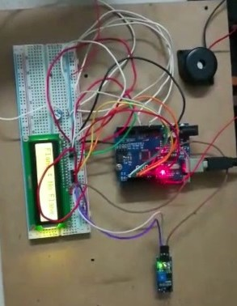

Fig 6.1:Connection Of Necessary Components

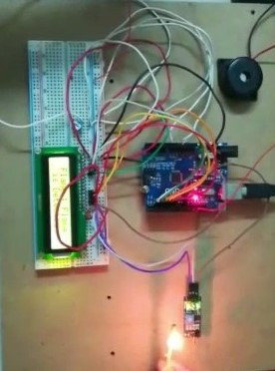Fig 6.2:**LCD displays that there is NO FLAME**.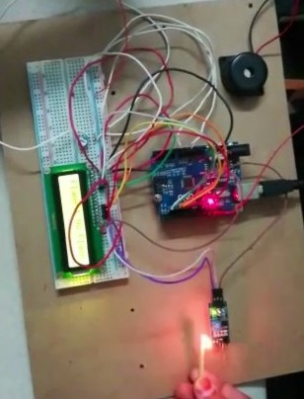 **fig 6.3: LCD displays Flame is Detected**

**CHAPTER 7**

**SOFTWARE TESTING**

Testing is the process of evaluating a system or its component(s) with the intent to find whether it satisfies the specified requirements or not. Testing is executing a system in order to identify any gaps, errors, or missing requirements in contrary to the actual requirements.

### Testing Principle

Before applying methods to design effective test cases, a software engineer must understand the basic principle that guides software testing. All the tests should be traceable to customer requirements.

### Testing Methods

There are different methods that can be used for software testing. They are,

#### Black-Box Testing

The technique of testing without having any knowledge of the interior workings of the application is called black-box testing. The tester is oblivious to the system architecture and does not have access to the source code. Typically, while performing a black-box test, a tester will interact with the system's user interface by providing inputs and examining outputs without knowing how and where the inputs are worked upon.

#### White-Box Testing

White-box testing is the detailed investigation of internal logic and structure of the code. White-box testing is also called glass testing or open-box testing. In order to perform white-box testing on an application, a tester needs to know the internal workings of the code. The tester needs to have a look inside the source code and find out which unit/chunk of the code is behaving inappropriately.

### Levels of Testing

There are different levels during the process of testing. Levels of testing include different methodologies that can be used while conducting software testing. The main levels of software testing are:

#### Functional Testing:

This is a type of black-box testing that is based on the specifications of the software that is to be tested. The application is tested by providing input and then the results are examined that need to conform to the functionality it was intended for. Functional testing of software is conducted on a complete, integrated system to evaluate the system's compliance with its specified requirements. There are five steps that are involved while testing an application for functionality.

* The determination of the functionality that the intended application is meant to perform.
* The creation of test data based on the specifications of the application.
* The output based on the test data and the specifications of the application.
* The writing of test scenarios and the execution of test cases.
* The comparison of actual and expected results based on the executed test cases.

#### Non-functional Testing

This section is based upon testing an application from its non-functional attributes. Non-functional testing involves testing software from the requirements which are non-functional in nature but important such as performance, security, user interface, etc. Testing can be done in different levels of SDLC. Few of them are

#### Unit Testing

Unit testing is a software development process in which the smallest testable parts of an application, called units, are individually and independently scrutinized for proper operation. Unit testing is often automated but it can also be done manually. The goal of unit testing is to isolate each part of the program and show that individual parts are correct in terms of requirements and functionality. Test cases and results are shown in the Tables.

#### Unit Testing Benefits

* + - * Unit testing increases confidence in changing/ maintaining code.
      * Codes are more reusable.
      * Development is faster.
      * The cost of fixing a defect detected during unit testing is lesser in comparison to that of defects detected at higher levels.
      * Debugging is easy.
      * Codes are more reliable.

Unit testing:

|  |  |
| --- | --- |
| Sl # Test Case : - | UTC-1 |
| Name of Test: - | Arduino Test |
| Items being tested: - | Power up the Arduino and boot |
| Sample Input: - | Turn on the Supply |
| Expected output: - | Arduino Should boot |
| Actual output: - | Power on test and upload successful |
| Remarks: - | Pass. |

|  |  |
| --- | --- |
| Sl # Test Case : - | UTC-2 |
| Name of Test: - | Sensors Test |
| Items being tested: - | Sensors Values Should change depending on Physical Changes |
| Sample Input: - | Tested for different inputs |
| Expected output: - | Should Show Proper Variation |
| Actual output: - | Variation detected |
| Remarks: - | Pass |

**Integration Testing:**

Integration testing is a level of software testing where individual units are combined and tested as a group. The purpose of this level of testing is to expose faults in the interaction between integrated units. Test drivers and test stubs are used to assist in Integration Testing. Integration testing is defined as the testing of combined parts of an application to determine if they function correctly. It occurs after unit testing and before validation testing. Integration testing can be done in two ways: Bottom-up integration testing and Top-down integration testing.

#### Bottom-up Integration

This testing begins with unit testing, followed by tests of progressively higher-level combinations of units called modules or builds.

#### Top-down Integration

In this testing, the highest-level modules are tested first and progressively, lower-level modules are tested thereafter.

In a comprehensive software development environment, bottom-up testing is usually done first, followed by top-down testing. The process concludes with multiple tests of the complete application, preferably in scenarios designed to mimic actual situations. Table 8.3.2 shows the test cases for integration testing and their results.

**Integration Testing:**

|  |  |
| --- | --- |
| Sl # Test Case : - | ITC-1 |
| Name of Test: - | Water Sprinkler Test |
| Item being tested: - | Water Spray |
| Sample Input: - | Input to fire sensor |
| Expected output: - | Should Extinguish fire when fire ismdetectd |
| Actual output: - | Fire Extinguished |
| Remarks: - | Pass. |

|  |  |
| --- | --- |
| Sl # Test Case : - | ITC-2 |
| Name of Test: - | DC Fan Test |
| Item being tested: - | Fan |
| Sample Input: - | Input to Gas and Fire Sensor |
| Expected output: - | Fan should turn on |
| Actual output: - | Fan turned on for gas leakage and fire detection |
| Remarks: - | Pass. |

**System testing:**

System testing of software or hardware is testing conducted on a complete, integrated system to evaluate the system's compliance with its specified requirements. System testing falls within the scope of black-box testing, and as such, should require no knowledge of the inner design of the code or logic. System testing is important because of the following reasons:

* + - * System testing is the first step in the Software Development Life Cycle, where the application is tested as a whole.
      * The application is tested thoroughly to verify that it meets the functional and technical specifications.
      * The application is tested in an environment that is very close to the production environment where the application will be deployed.
      * System testing enables us to test, verify, and validate both the business requirements as well as the application architecture.

System Testing is shown in below tables

System testing:

|  |  |
| --- | --- |
| Sl # Test Case : - | STC-1 |
| Name of Test: - | System testing with all sensors and output Sections turned on |
| Item being tested: - | Alarm and Intimation |
| Sample Input: - | Input to Sensors |
| Expected output: - | Synchronization and update |
| Actual output: - | Intimation and Alarm Initiated for critical situations |
| Remarks: - | Pass |

**Acceptance Testing**

Acceptance testing is actually a series of different tests whose primary purpose is to fully exercise the computer-based system. Include recovery testing crashes, security testing for unauthorized user, etc.

Acceptance testing is sometimes performed with realistic data of the client to demonstrate that the software is working satisfactorily. This testing in FDAC focuses on the external behavior of the system.

|  |  |
| --- | --- |
| Test Case ID | System Test Case 1 |
| Description | Industrial Automation |
| Input | Threshold value |
| Expected output | Process should work according to Input criteria |
| Actual Result/Remarks | Working as expected output. |
| Passed (?) | Yes |

**Acceptance Testing**

**Validation Testing**

At the culmination of integration testing, software is completely assembled as a packages; interfacing errors have been covered and corrected, and final series of software tests-validating testing may begin. Validation can be defined in many ways, but a simple definition is that validation succeeds when software functions in a manner that can be reasonably expected by customers. Reasonable expectation is defined in the software requirement specification- a document that describes all users’ visible attributes of the software. The specification contains a section title “validation criteria”. Information contained in that section forms the basis for validation testin

**CHAPTER 8**

**CONCLUSION**

In this Project, an attempt has been done to design a fire alarm system using Temperature sensor and Micro controller for efficient use of electricity. It will help to reduce the wastage of electricity, save lives, reduce percentage of accident and reduce waste of electric appliance. The results obtained from the measurement have shown that the system perform well under all the conditions.

The main objective of this project has been to design a circuit that detects high temperature and consequently triggers an alarm, switch off the mains of the building. These objectives were met since the systems works effectively.

This project has been made in order to help building owner to overcome the problem which is fire spreading whenever the owner is not in the building. The unpredictable situation or critical situation always occurs in the building or resident areas without the residents’ notice. Based on the results obtained, the home alert system is doable and functional to the residents to protect their houses. In fact the system built is cheap in value compared to other existing alarm system in the market and easy to apply to the houses.

**CHAPTER 9**

**FUTURE ENHANCEMENT**

The developed prototype in this work is made for a user to control the fire alarm system remotely. This helps the user if he/she is not in the building or even unaware of emergency condition. The use of this prototype will avoid the unpredictable situation or any critical situation from occurring in the residential areas without awareness of the resident. The use of coupled sensor of temperature sensor and smoke detector was found to be more appropriate than the use of only one of them. Though the prototype was able to extinguish the fire but the portability can be significantly improved by an efficient assimilation of the different modules. This system should also take care that each module of it can be easily replaced by a better sensor and equipment with updated technology. The microcontroller can be programmed with the contact number of local authorities of fire brigade.

Besides notification to the fire department the smart real time fire and smoke detection system can have lot of additional functions, since this processor can support even digital signal processing. Some of the additional function examples are listed below:

1. Can use digital signal processing (DSP) to predict fire.
2. Supervision of fire sprinkler systems.
3. Surveillance of control valves.
4. Indication of water flow.
5. Monitoring of fire pumps.
6. Release of fire doors.
7. Release of some extinguishing systems.
8. SActivation of smoke control systems.

#### **BIBLIOGRAPHY**

1.Adekunle A., Umanah I.I., Ibe K.E. and Imonikosaye M.R. (2018) Statistical analysis of fire outbreaks in homes and public buildings in Nigeria. A Case Study of Lagos State, (pp. 21 - 30).

2.Amy, T., et al. (2019) Boston fire of 1872.encyclopedia of world history. Retrieved from https://[www.britannica.com/event/Boston-fire-of1872](http://www.britannica.com/event/Boston-fire-of1872) 3. Sarah, B. ( 2017) The great fire of nero and the ancient history of firefighting. Retrieved from https://[www.forbes.com/emperor-nero,.](http://www.forbes.com/emperor-nero)

3.Erik, A.. Influential innovator. Ctesibius, (2016).

4.Huang, Y., Zhang, W., Dai, X., Zhao Y. (2012). Study on water-based fire extinguishing agent formulations and properties. International Symposium on Safety Science and Technology, (pp. 650 - 654) 6. Shehab, J. N. (2018) Design and Implementation of Factory Security System. (PP. 162 - 171)

5.Qin, W. Jiashuo, C. and Chuang, Z. (2018) Intelligent Smoke Alarm System with Sensor Network Using ZigBee, (pp. 1 - 10)

6.Aydin, B., Selvi, E., Tao, J. and Starek, M. J. (2019) Use of Fire-Extinguishing Balls for a Conceptual System of Drone-Assisted Wildfire Fighting, (PP.1 - 15)

7.Bahrepour, M., Meratnia, N. and Havinga, P. (n,d).A Survey From Wireless Sensor Network Perspective, Automatic Fire Detection.

8.Shin-Juh, C., Chris, H., Kristen A. P. and André, M. (2007) Fire detection using smoke and gas sensors, (PP. 2 - 19)

9.Sonsale, p., Gawas, R., Pise, S. and Kaldate, A. (2014). Intelligent Fire Extinguisher System. (pp. 59 - 61)

10. Warmack, R. J., Dennis, W. and Shane, F. (2015). Using Linear Discriminant Analysis. Smart Smoke Alarm, FEMA (5 - 30)